**GAIT Analysis**

**Final Report**

**Submitted by**: Assaf Lovton, Eden Dembinsky, and Ron Rubinstein.

**Supervised by:** Itay Dabran, Nitzan Breitman, and Ofir Elmakias.

Table of Contents

Abstract 3

1. Introduction 3

1.1 General Project Description 3

1.2 Programming Environment 3

2. Theoretical Background 3

2.1 Step Phases 3

2.2 Identifying Step Phases 4

3. Basic System Functionalities 6

4. Software Implementation 7

5. Tests and Results 8

6. Future Directions 8

7. Summary 8

8. References 8

# 

# Abstract

Our goal in this project is to improve ankle sprain recovery, by identifying key phases in the patient’s walking-cycle and activating a vibration motor placed on a key nerve in the leg. This is done by connecting a gyroscope to the leg and running a dynamic algorithm that monitors the patient’s steps in real-time to identify these phases.

# Introduction

## General Project Description

Ankle sprains are one of the most common injuries among athletes, combat soldiers and active populations. This injury causes pain that is correlated with a reduced range of motion while recovering, which results in back pains, knee problems and more.

We are developing a novel affordable wearable device using vibration stimulus that overrides that pain signal to the spine, reducing pain and increasing range of motion.

## Programming Environment

Our project includes static analysis of the angular velocity of the injured leg during walking, done in PyCharm, as well a real-time Gait analysis that operates a vibration motor, using an Arduino Nano BLE.

# Theoretical Background

## Step Phases

To override the pain signal, while not causing the brain to ignore the vibration due to constant stimulus, we need to accurately identify the exact ranges that are painful during the step.

Figure 1: The figure above depicts the different phases of a step.

The three stages that interest us are the Mid-Swing (MS), Heel Strike (HS) and Toe Off (TF/TO).

We aim to identify these stages in real-time using sensors placed on the injured leg and apply the vibration between the HS and TF phases, where it is most painful.

## 2.2 Identifying Step Phases

Using a gyroscope connected to the injured leg, we can measure the angular velocity of the leg and identify the different stepping phases.

Figure 2: (App screenshot) The graph above depicts the angular velocity of the leg and algorithm results.

We can compare the leg to two moving pendulums as seen in the following figure.

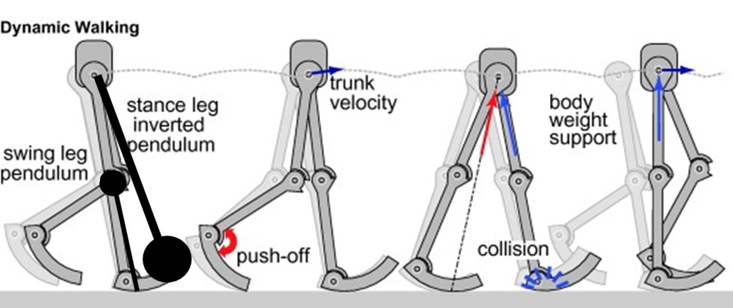  
Figure 3

In the MS stage, the larger pendulum is swinging, and the axis of rotation is the hip. We can identify this stage in each step by the maximums in angular velocity as seen in Figure 2.

The HS stage causes the foot to stay in place on the stepping surface, while the hip and knee continue moving forward. This effect causes a “flip” in the pendulum, which is represented by the upside-down pendulum in the above figure. This is because the heel becomes the axis of rotation, and the radius of rotation has decreased as well.

We see the described effect in the graph as a change in the direction of the angular velocity (which is now negative). Studies have shown that the HS can be defined as the first Minimum point after the flip in velocity direction.  
Afterward, we see the TO stage when the foot disconnects from the ground, and we get positive velocity again. Therefore, we can define the TO stage as the global minimum in each step before the direction change.

# Basic System Functionalities

Figure 4: The project circuit including a transistor, vibration motor and Arduino nano sense BLE board.

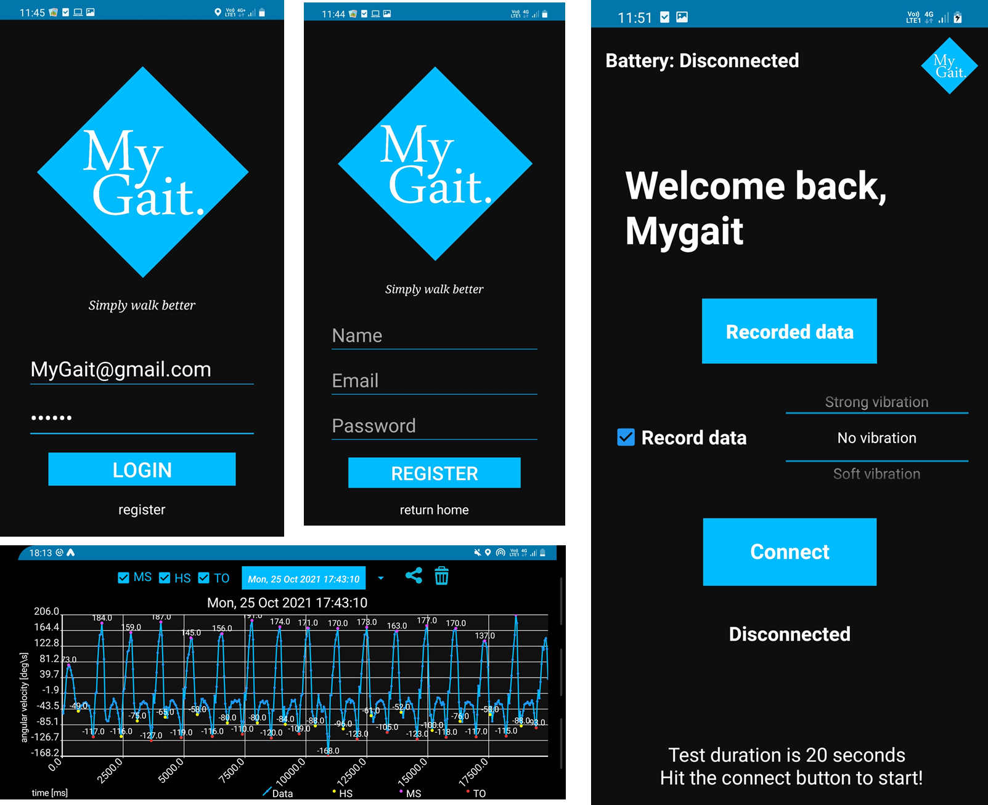Our project functionalities include an Arduino Nano sense BLE connected to the injured leg, which senses the angular velocity using a gyroscope, identifies the relevant stepping stages and acts as a switch for a connected vibration motor.  
Additionally, our project includes an application which the Arduino Nano can connect to using the BLE protocol.

Figure 5: App login, registration, main and data analysis screens.

The application offers many functionalities:

-The app supports user authentication using firebase, with responsive input checking (missing details, user already registered, email already taken, password less than 6 characters and more).

-The usage of firebase cloud services allows the researcher to get a full access to all patients data in a JSON file.

- The app can request a recording of the angular velocity data and presents it as a readable graph including the different stepping phases. Moreover, it allows to remove labels if needed.

- The app uploads all the user’s recordings to the Firebase cloud, making them freely accessible in the future as JSON file.

- The app allows us to modify the vibration level of the motor.

- The app presents the Arduino board Battery Level.

- The app offers an interactive user interface – describing the connection status with the board and a dynamic guide for data recording option.

-The app allows to share the results as csv file or an image.

-The app allows to manage the patient file – deleting unwanted samples.

- The app includes a rotating logo.

# Software Implementation

To implement the identification algorithm on the Arduino we first conducted many recordings of data and studied them statically in the SimulateAlgoOnData.py file, which simulates the Arduino algorithm and is logically identical to the Arduino code that runs in real time.

The code, which is well documented in the Arduino file “arduinoCode.ino”, works by doing the following:

* Averaging real-time measurements to eliminate noise.
* Looking for MS/HS/TO states by searching for maxima and minima points.
* Updating timing and velocity thresholds for each state dynamically to adjust to changing walking speeds.
* Using moving averages and measurement filters so we only use the valid measurements as opposed to “sudden-change” measurements that can potentially offset our thresholds.
* Activating the vibration motor according to the identified states, between HS and TO.
* Auto-restarting when missing a step due to sudden speed change.

# Tests and Results

Testing the final product resulted in accurate vibrations between 80-90% of the steps, while all application functionalities work well. We noticed that changing walking direction challenged our algorithm and caused the restart functionality in the algorithm to be activated, which returned us to the appropriate activity.

# Future Directions

Both the python simulation and the Arduino code contain constants at the beginning of the file that can be adjusted to improve the algorithm. These constants include update rates to the moving averages, and acceptable flexibility rates for different parameters. Testing different values for these parameters can be done to further optimize performance.  
When satisfactory results are achieved, a parameter-restart that occurs every 20 seconds can be canceled (The RESTART_THRESH constants both in the python and the Arduino).

# Summary

We found this project to be very interesting, due to the variety of fields that were researched and incorporated. From the physics of walking and in-depth algorithmic research to communication using BLE and cloud-based application building, all these areas required different tools and capabilities. Our good teamwork allowed us to focus on different aspects of the project according to each of our interests and collaborate to connect it all into one working product.

# References

1. Doherty *et al., Sport Med*. 2014
2. Punt *et al.*, *PM&R*. 2015
3. Aiken *et al.*, *J Orthop Sports Phys Ther*. 2008
4. R, Melzack, and Wall P.D, Science. 1965
5. Gait cycle figure: Stöckel et al. Front Psychol. 2015
6. Wang, F.-C.; Li, Y.-C.; Wu, K.-L.; Chen, P.-Y.; Fu, L.-C. Online Gait Detection with an Automatic Mobile Trainer Inspired by Neuro-Developmental Treatment. Sensors 2020, 20.